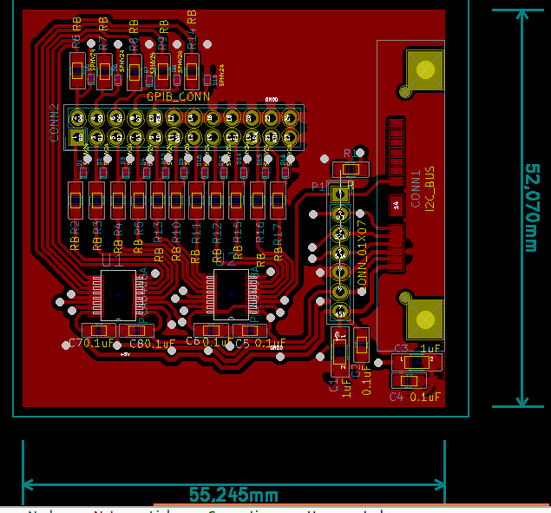Illustration 1: Vista de capa superior (TOP)
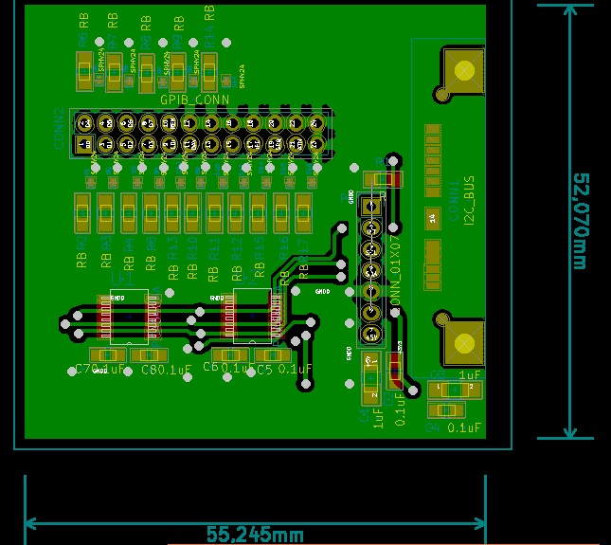Illustration 2: Vista de capa inferior (BOTTOM)

